STEP FOUR
I make a searching and fearless moral inventory of myself.
Excerpt from Twelve Steps and Twelve Traditions: A fearless moral inventory must seem to every newcomer that more is being asked of him than he can do. Both his pride and his fear beat him back every time he tries to look within himself. Pride says, "You need not pass this way," and Fear says, "You dare not look!" But the testimony of those who have really tried a moral inventory is that pride and fear of this sort turn out to be bogeymen, nothing else. Once we have a complete willingness to take inventory, and exert ourselves to do the job thoroughly, a wonderful light falls upon this foggy scene. As we persist, a brand-new kind of confidence is born, and the sense of relief at finally facing ourselves is indescribable. These are the first fruits of Step 4.
Victory Group Note: At this step in recovery, some choose not to continue with Step 4. If you are not ready to take this step, that is okay. You are still loved and accepted at Victory Group. Feel free to join a regular discussion group and start this step when you are ready. However, before you make a decision to pull back at this point, please discuss your choice with your sponsor and with your group leader. We are here to encourage and help you work your recovery.
A personal inventory is crucial to understanding the new direction of our spiritual growth. What aspect of our character do we need to retain and emphasize, and what should be modified or discarded? Six components that might go into such an inventory are described in the following paragraphs.
First, we may need to "tell our stories." This can be accomplished by journaling, that is, by writing out our stories, and by sharing them with others in recovery meetings or private dialogue. In John 4, there is a beautiful passage on "The Woman at the Well." When the Samaritan woman encountered Jesus, she was amazed that He had anything to do with her, since Jews generally had no dealings with Samaritans. Then, he told her that He knew everything about her; the full story of her life; that she had had five husbands and that she was then living with a man who was not her husband. The fact that Jesus, with full knowledge of her life story, accepted her and loved her unconditionally was a life-transforming experience.
Preparing our stories allows us to assess the major events of our lives. Knowing the steps of our past journeys helps us to honestly evaluate our present situations. Sharing our stories may enable others to better understand us and may open new avenues through which they can touch and heal our lives.
A second component of our inventory is discovering the roots of our addictions and codependencies. In most cases, this means we have to examine our childhoods. What needs were not met there? What negative experiences or messages about ourselves did we absorb in our dysfunctional family of origin? There are six types of family of origin dysfunction that can generate or create a later adult addiction or codependency:
- ACTIVE ABUSE. A parent's pain or frustration is discharged against or projected onto the child. Any form of direct physical, verbal, or sexual abuse can be classified as active abuse.
- PASSIVE ABUSE. Passive abuse occurs when key elements are missing within the family. A child growing up needs fifteen years of steady, consistent loving from two sane, sober, relatively happy parents. Anything, such as workaholism, that hinders or limits the parents' ability to give these things can result in passive abuse.
- EMOTIONAL INCEST. Typically, in families where one or both parents are in some way emotionally or physically disabled, a young child will begin to assume parental or spousal responsibilities toward the parent. For example, if seven year-old Suzie's mother is an alcoholic, Suzie may begin getting herself up for school, fixing her own breakfast, and urging her mother out of bed in the afternoon to keep peace with Daddy. Suzie is becoming a mother to her own mother.
- UNFINISHED BUSINESS. If parents have not made peace with disillusionments, defects, or limitations in their own lives, the child may pick up their unfinished business. A father who is frustrated and unsuccessful in his work may push his sons and daughters to be compulsive, a perfectionist, and/or a workaholic in order to compensate for his own limitations.
- NEGATIVE MESSAGES about who and what the child is. These are spoken and experienced messages that destroy feelings of self-worth and become part of the child's personality. Examples of spoken messages are: "You'll never amount to anything." "Can't you do anything right?" An experienced message is felt by the child whose father spends an excessive amount of time with his work and little or no time with the child.
- SPLIT-OFF FEELINGS OR NEEDS. In dysfunctional families, members deny their feelings and bury their needs. These needs will later try to assert themselves, but may do so in very damaging ways. For example, a wife who assumes a passive role and buries her needs to be assertive in marriage may eventually become passive-aggressive and take out her anger by abusing credit cards and overspending.
Even though these six types of dysfunction refer to the family of origin, some could easily apply to abuse from others that were involved in our childhoods or young lives. For example, negative messages could be received from classmates or neighbors, a boyfriend could have been physically or emotionally abusive, or a family friend could have been sexually abusive, etc.

These dysfunctions can be a root cause of our addiction. However, they are not the only causes. Even with a relatively healthy family life, peer pressure may have pushed us to experiment with drugs. A strong urge to live on the edge could also lead us to unhealthy choices. There is a myriad of other reasons that could have led us to make the choices that we did. Only you know what those reasons are for you.
Learning what was damaged or missing in our childhoods is not an attempt to blame the previous generation. Rather, it is a genuine effort to understand the deepest root causes that underlie our compulsive adult behavior.
Third, we must confront and assess the full extent of our dependencies. Doing so, we will learn more about the severity of our primary addictions, and we may uncover other peripheral addictions we had not previously recognized. We should inventory and identify all of those codependent symptoms and addictions, which have manifested themselves in our adolescent and adult lives. As we perform our fourth step inventory, we must be certain to identify all the possible addictions affecting our lives. See the "Possible Addictive Agents" list that is attached.
Fourth, we need to look back at our relationship history with the people who have been significant in our lives—parents, teachers, mentors, friends, romantic interests. We need to inventory all the ways we have hurt them and hurt ourselves by practicing our addictions and co-dependencies. This is a step toward ridding our lives of resentments and guilt.
Resentments which arise out of fear and insecurity, may lie behind much of the hurt we have inflicted on others and on ourselves. As part of this fourth inventory component, we must first acknowledge our resentments and then identify the fears and insecurities that underlie them. Only in this manner can we deal effectively with these resentments that will otherwise fester like emotional cancers.
Fifth, we must address our guilt feelings. We realize that most addictions are shame-based, and we need to distinguish between two major forms of guilt:
- FALSE SHAME, OR CARRIED SHAME. This is undeserved blame that we have taken upon ourselves for people or situations over which we may have had no control. Adult children of dysfunctional families often carry an enormous residue of false guilt for their parents' dysfunctions.
- AUTHENTIC GUILT. As adults and sinners, we have probably hurt many people in many ways. We have caused this hurt through things we have said, through things we have done, and through things we have left undone.
We need to distinguish between these two types of guilt, handing back the false shame and recognizing those areas of authentic guilt for which we need to ask for forgiveness.
Sixth, we must "look for the good." An important counterbalancing dimension is that a Step 4 inventory should include the positive, as well as the negative things about us:
- What positive legacies have we derived from our childhood and adolescence?
- What positive survival mechanisms have emerged from our struggles to cope? For example, the compulsive, overachieving student may possess the positive legacies of being a good academician with strong job skills.
- What are our skills, talents, gifts, and attributes?
- What positive permissions have we granted to ourselves (permission to live, permission to be healthy, permission to recover, permission to experience relative happiness in adult life)?
- What positive recovery steps and changes are currently being implemented in our lives?
NOTE: Perhaps in taking our inventories, we have now uncovered certain addictions or dependencies we did not previously recognize. If so, we may need to return to Step 1 to address these.

Possible Addictive Agents
In the list below, the asterisk* denotes socially acceptable addictions—which can be somewhat camouflaged. Note: this is not a complete list.
- Chemical Addictions (alcohol, drugs, cigarettes)
- People* Addictions (co-dependency, the need to please people, rescuing patterns toward other persons, dependency on damaging/hurtful relationships)
- Control addictions (personal, sexual, family, business relationships)
- Food addictions (compulsive overeating, Bulimia, Anorexia)
- Self-mutilation, hair pulling
- Narcissism, cosmetics*, clothes*, cosmetic surgery*, trying to look good on the outside*
- Addiction to imagined or real defect in appearance
- Obsessive-compulsive symptoms like cleaning and avoiding contaminations, general perfectionism, over organizing*, structuring (must have everything in its place)
- Excessive exercise, body building*, anabolic steroids
- Sexual addictions (sex, voyeurism, pedophilia, exhibitionism, etc.)
- Money addictions (overspending, gambling, hoarding, materialism, shopping*, collecting*, etc.)
- Work*, achievement*, success*, hobbies*
- Hypochondria
- Academic pursuits* and excessive intellectualizing
- Theft, vandalism, con-men, compulsive and impulsive lying, violence, hate, racism
- Risk-taking*
- Internet addiction*: a composite of people addiction, "falling in love" addiction, sex addiction, risk addiction, and hobby addiction
- Religiosity or religious legalism (preoccupation with the form and the rules and regulations of religion, rather than benefiting from the real spiritual message, or denying the power of God)

Victory Group Note: Your personal inventory is NOT shared in the Victory Group 12-Step Discussion Group. To complete Step 5 (I admitted to God, to myself, and to another human being the exact nature of my wrongs) you share your inventory with someone you personally select.

FOURTH STEP INVENTORY
From: http://www.recovery.org/aa/PDF/step4.pdf

One of the requirements for sobriety is the need for confession of personality defects, a moral inventory, and step four is designed to be just this. There is a lot of hype and fear surrounding this step (mostly created by those who are yet to do it), and these worksheets are designed to make this task as easy and simple as possible. Everything contained in these sheets is directly from the Big Book 'Alcoholics Anonymous'; there is no opinion, just fact. To be able to start on this step, the previous three steps must, of course, have been completed, so before starting check with your sponsor, spiritual advisor, counselor, etc. to make sure you are ready.
Many people get loaded or act out in some way when they reach this step. Why? They will tell you that the pain of dredging up memories long buried was too much to endure, or any one of a thousand other excuses. The plain and simple fact is just this: the pain does not come in writing this inventory; the pain comes in resisting the writing. Alcoholics and addicts, time after time, would rather get loaded again than have to face some inner truths. The freedom from self is made impossible by holding on to fears and secrets we've harbored all our lives; the way of strength, paradoxically, is in becoming vulnerable.
Here are some tips to help you with this moral inventory:

Try to list resentments in groups, i.e.; family, school, relationships, work, etc.

If you are not sure in any area, call somebody and ask about his or her experience.

Get into the habit of writing every day, even if it's only for ten minutes.

In the resentment inventory, don't write across, write in columns, i.e.; all names first, all causes second, etc.

Be honest! The only person to truly benefit from this exercise is you; don't cheat yourself out of this incredible experience.

RESENTMENT INVENTORY PROMPT SHEET

Here is a list of people, institutions, and principles that may be helpful
in your resentment inventory. Feel free to add to the lists if you need to.

PEOPLE
Father (Step)
Mother (Step)
Sisters (Step)
Brothers (Step)
Aunts
Uncles
Cousins
Clergy
Police
Lawyers
Judge
Doctors
Employers
Employees
INSTITUTIONS

Marriage
Bible
Church
Religion
Races
Law
Authority
Government
Education System
Correctional System
Mental Health System
Philosophy
Nationality

PRINCIPLES

God-Deity
Retribution
Ten Commandments
Jesus Christ
Satan
Death
Life After Death
Heaven
Hell
Sin
Adultery
Golden Rule
Original Sin
Seven Deadly Sins

In-Laws
Husbands
Wives
Co-Workers
Creditors
School Friends
Teachers
Lifelong Friends
Acquaintances
Childhood Friends
Best Friends
Girlfriends
Boyfriends
Parole Officers
Probation Officers
A.A. Friends
C.A. Friends
N.A. Friends
U.S. Service Friends

FEAR INVENTORY PROMPT SHEET

Here is a list of fears that may be helpful in your fear inventory.
Feel free to add to the lists if you need to.

Fear of God
Fear of Dying
Fear of Insanity
Fear of Insecurity
Fear of Rejection
Fear of Loneliness
Fear of Diseases
Fear of Alcohol
Fear of Drugs
Fear of Relapse
Fear of Sex
Fear of Sin
Fear of Self-Expression
Fear of Authority
Fear of Heights
Fear of Unemployment
Fear of Employment
Fear of Parents
Fear of Losing A Wife
Fear of Losing A Husband
Fear of Losing A Child
Fear of Animals
Fear of Insects
Fear of Police
Fear of Jail
Fear of Doctors
Fear of Stealing
Fear of Creditors
Fear of Being Found Out
Fear of Homosexuals & Lesbians
Fear of Failure
Fear of Success

Fear of Drowning
Fear of Men
Fear of Women
Fear of Being Alone
Fear of People
Fear of Crying
Fear of Poverty
Fear of Races
Fear of The Unknown
Fear of Abandonment
Fear of Intimacy
Fear of Disapproval
Fear of Rejection
Fear of Confrontation
Fear of Sobriety
Fear of Hospitals
Fear of Feelings
Fear of Getting Old
Fear of Hurting Others
Fear of Violence
Fear of Writing Inventory
Fear of Being Alive
Fear of Government
Fear of Gangs
Fear of Gossip
Fear of Wealthy People
Fear of Guns
Fear of Change
Fear of Responsibility
Fear of Physical Pain
Fear of Fear

FOURTH-STEP INVENTORY
RESENTMENTS, FEARS, AND SEXUAL CONDUCT/HARM DONE TO OTHERS

RESENTMENTS
Please read from the bottom of page 63 through page 65 in the attached Big Book, Chapter 5, before beginning.
Column 1: Resentments
List all people, places, things, institutions, ideas, or principles with whom you are angry, resent, feel hurt or threatened by.
Column 2: The Cause
What happened? Be specific as to why you were angry.
Column 3: Affects My...
How did it make me feel? Specifically, how did it affect the seven parts of self?
Column 4: Where Was I to Blame?
Read through the second paragraph on page 67 before answering this.
What's the truth here? Where was my responsibility in this relationship? What might I have done instead? Where was I at fault?

FEARS
Read the Big Book, page 67, last paragraph through first paragraph on page 68.
List your fears. Then write about why you have each fear. Has self-reliance failed you?

SEXUAL CONDUCT/HARM DONE TO OTHERS
Read carefully Big Book pages 68-70.
Again, make a list for yourself. What happened in each instance? How did it make you feel?

The Seven Parts of Self Defined
Self Esteem - How I think of myself
Pride - How I think others view me
Pocketbook - Basic desire for money, property, possessions, etc.
Personal Relations - Our relations with other people
Ambition - Our goals, plans, and designs for the future
Emotional Security - General sense of personal well-being
Sex Relations - Basic drive for sexual intimacy

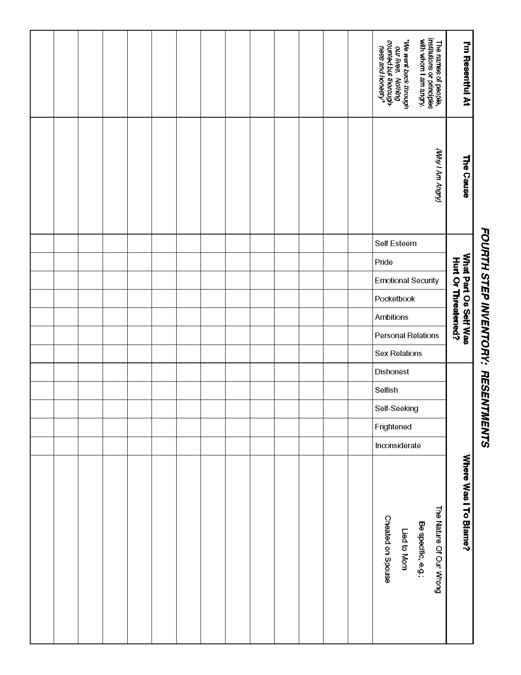

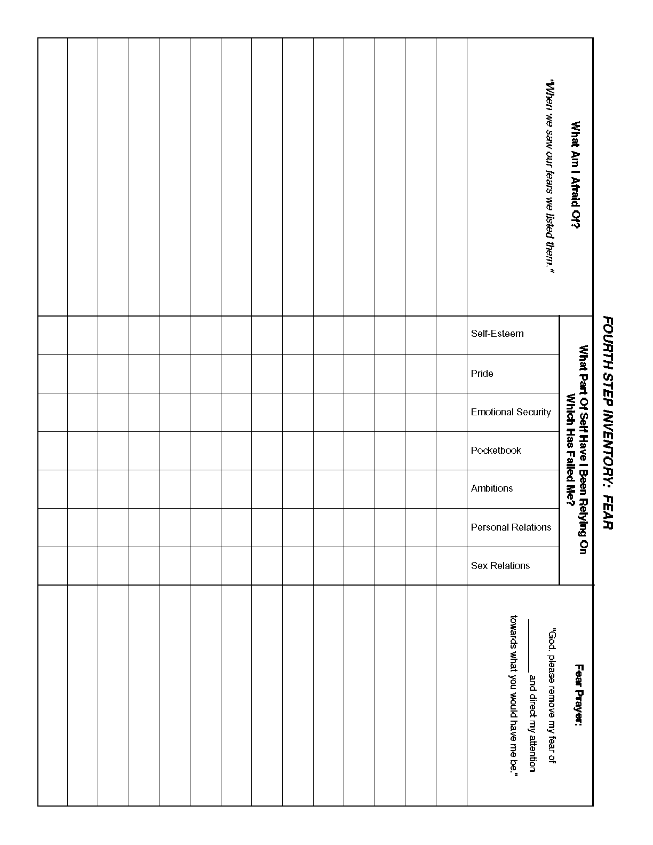
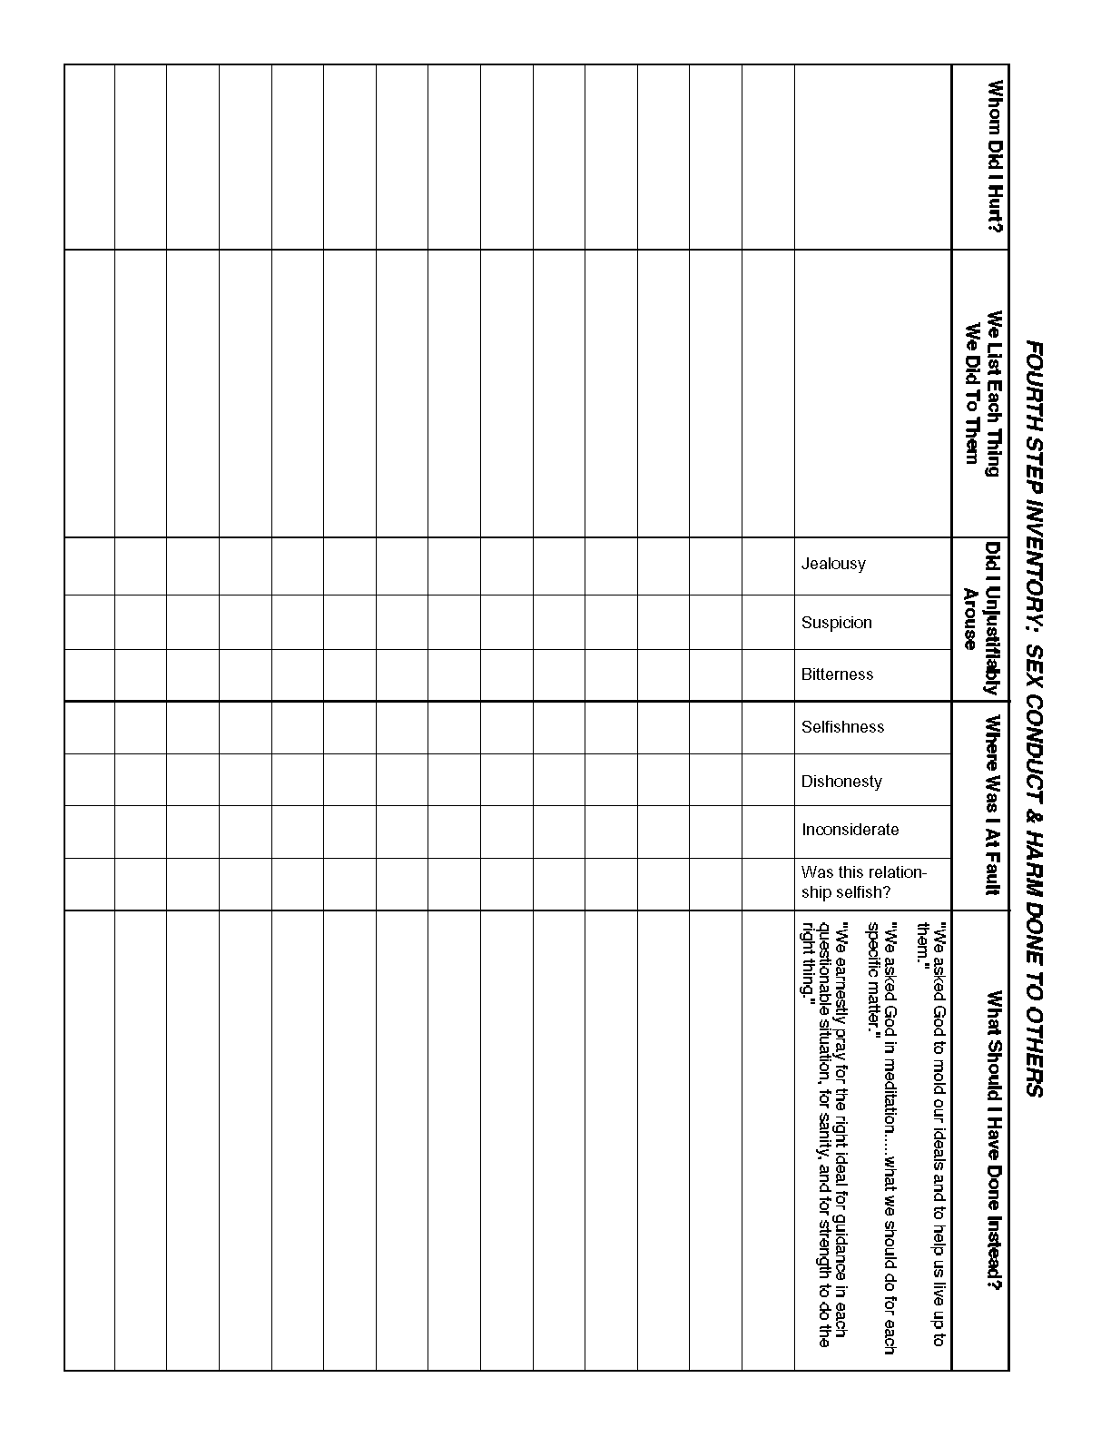
ASSETS WORKSHEET EXAMPLE
This worksheet can help you take a relatively objective look at your progress in recovery. In the "Assets and other Status" column, you list the material and emotional aspects of your life. In the dated columns, you rate from "0 to 10" how well you feel you are doing in this area of your life on this date in time.
In this example, you can see we all need to start somewhere, but with God's help we can grow and change. As we update this chart, it allows us to recall the miraculous improvements in our lives.
 | Fill in date and your rating in the columns below:
ASSETS & OTHER STATUS | 1/3/1982 | 1/1/1990 | 6/3/1993 | 8/5/1996 | 3/11/1999
Health—Mental | 1 | 3 | 5 | 7 | 8
Health—Physical | 1 | 2 | 4 | 6 | 8
Health—Spiritual | 5 | 5 | 7 | 7 | 8
Relationships—Spouse | 1 | 1 | 6 | 8 | 9
Relationships—Family | 1 | 1 | 5 | 8 | 9
Relationships—Friends | 3 | 4 | 5 | 7 | 8
Housing | 1 | 4 | 4 | 7 | 8
Vehicle | 1 | 2 | 4 | 6 | 8
Driver's License | 0 | 10 | 10 | 10 | 10
12 Steps | 2 | 3 | 5 | 7 | 9

ASSETS WORKSHEET
In the "Assets and other Status" column, list the material and emotional aspects of your life (some have already been filled in for you). In the dated columns, you rate from 0 to 10 how well you feel you are doing in this area of your life on this date in time. As you update this worksheet in your recovery, you can see the miraculous improvements in your life. For I know the plans I have for you," declares the LORD, "plans to prosper you and not to harm you, plans to give you hope and a future. Jeremiah 29:11 (NIV).
Fill in date and your rating in the columns below:
ASSETS & OTHER STATUS
Health—Mental
Health—Physical
Health—Spiritual
Relationship—Spouse
Relationships—Family
Relationships—Friends
Housing
Vehicle
Driver's License
12 Steps

CHARACTER ASSETS

Make a list of situations where you recently exhibited a positive character asset. Example: Mary / I helped her move / Generosity / I felt good to be there for her because she has a bad back and couldn't move all by herself. Another example: Work / I showed up when I was tired / Reliability / I was glad I did what was right.

Person, place, thing, situation? | What happened? | Character Asset | How do you feel about this?

Chapter 5 (Alcoholics Anonymous Big Book)*

*Copied from: http://www.recovery.org/aa/bigbook/ww/chapter_5.html. Page numbers are listed for the approximate Big Book location to help you find what you need to read to complete your inventory above.

(PAGE 58) How It Works
Rarely have we seen a person fail who has thoroughly followed our path. Those who do not recover are people who cannot or will not completely give themselves to this simple program—usually men and women who are constitutionally incapable of being honest with themselves. There are such unfortunates. They are not at fault; they seem to have been born that way. They are naturally incapable of grasping and developing a manner of living which demands rigorous honesty. Their chances are less than average. There are those, too, who suffer from grave emotional and mental disorders, but many of them do recover if they have the capacity to be honest.
Our stories disclose in a general way what we used to be like, what happened, and what we are like now. If you have decided you want what we have and are willing to go to any length to get it—then you are ready to take certain steps.
At some of these we balked. We thought we could find an easier, softer way. But we could not. With all the earnestness at our command, we beg of you to be fearless and thorough from the very start. Some of us have tried to hold on to our old ideas and the result was nil until we let go absolutely.
(PAGE 59) Remember that we deal with alcohol—cunning, baffling, powerful! Without help it is too much for us. But there is One who has all power—that One is God. May you find Him now!
Half measures availed us nothing. We stood at the turning point. We asked His protection and care with complete abandon. Here are the steps we took, which are suggested as a program of recovery:

- We admitted that we were powerless over alcohol, that our lives had become unmanageable.  - Came to believe that a Power greater than ourselves could restore us to sanity.  - Made a decision to turn our will and our lives over to the care of God as we understood Him.  - Made a searching and fearless moral inventory of ourselves.  - Admitted to God, to ourselves, and to another human being the exact nature of our wrongs.  - Were entirely ready to have God remove all these defects of character.  - Humbly asked Him to remove our shortcomings.  - Made a list of all persons we had harmed and became willing to make amends to them all.  - Made direct amends to such people wherever possible, except when to do so would injure them or others.  - Continued to take personal inventory, and when we were wrong, promptly admitted it.  - Sought through prayer and meditation to improve our conscious contact with God as we understood Him, praying only for knowledge of His will for us and the power to carry that out.  - Having had a spiritual awakening as the result of these steps, we tried to carry this message to others, and to practice these principles in all our affairs. | The  12  Steps

(PAGE 60) Many of us exclaimed, "What an order! I can't go through with it." Do not be discouraged. No one among us has been able to maintain anything like perfect adherence to these principles. We are not saints. The point is, that we are willing to grow along spiritual lines. The principles we have set down are guides to progress. We claim spiritual progress rather than spiritual perfection.
Our description of the alcoholic, the chapter to the agnostic, and our personal adventure before and after make clear three pertinent ideas:
 | (a) | That we were alcoholic and could not manage our own lives.
 | (b) | That probably no human power could have relieved our alcoholism.
 | (c) | That God could and would if He were sought.
Being convinced, we were at Step Three, which is that we decided to turn our wills and our lives over to God as we understood Him. Just what do we mean by that, and just what do we do?
The first requirement is that we be convinced that any life run on self-will can hardly be a success. On that basis we are almost always in collision with something or somebody, even though our motives are good. Most people try to live by self-propulsion. Each person is like an actor who wants to run the whole show; is forever trying to arrange the lights, the ballet, the scenery, and the rest of the players in (PAGE 61) his own way. If his arrangements would only stay put, if only people would do as he wished, the show would be great. Everybody, including himself, would be pleased. Life would be wonderful. In trying to make these arrangements, our actor may sometimes be quite virtuous. He may be kind, considerate, patient, generous; even modest and self-sacrificing. On the other hand, he may be mean, egotistical, selfish and dishonest. But, as with most humans, he is more likely to have varied traits.
What usually happens? The show doesn't come off very well. He begins to think life doesn't treat him right. He decides to exert himself more. He becomes, on the next occasion, still more demanding or gracious, as the case may be. Still the play does not suit him. Admitting he may be somewhat at fault, he is sure that other people are more to blame. He becomes angry, indignant, self-pitying. What is his basic trouble? Is he not really a self-seeker even when trying to be kind? Is he not a victim of the delusion that he can wrest satisfaction and happiness out of this world if he only manages well? Is it not evident to all the rest of the players that these are the things he wants? And do not his actions make each of them wish to retaliate, snatching all they can get out of the show? Is he not, even in his best moments, a producer of confusion rather than harmony?
Our actor is self-centered, ego-centric, as people like to call it nowadays. He is like the retired business man who lolls in the Florida sunshine in the winter complaining of the sad state of the nation; the minister who sighs over the sins of the twentieth century; politicians and reformers who are sure all (PAGE 62) would be Utopia if the rest of the world would only behave; the outlaw safe cracker who thinks society has wronged him; and the alcoholic who has lost all and is locked up. Whatever our protestations, are not most of us concerned with ourselves, our resentments, or our self-pity?

Selfishness—self-centeredness! That, we think, is the root of our troubles. Driven by a hundred forms of fear, self-delusion, self-seeking, and self-pity, we step on the toes of our fellows and they retaliate. Sometimes they hurt us, seemingly without provocation, but we invariably find that at some time in the past we have made decisions based on self which later placed us in a position to be hurt.
So our troubles, we think, are basically of our own making. They arise out of ourselves, and the alcoholic is an extreme example of self-will run riot, though he usually doesn't think so. Above everything, we alcoholics must be rid of this selfishness. We must, or it kills us! God makes that possible. And there often seems no way of entirely getting rid of self without His aid. Many of us had moral and philosophical convictions galore, but we could not live up to them even though we would have liked to. Neither could we reduce our self-centeredness much by wishing or trying on our own power. We had to have God's help.
This is the how and the why of it. First of all, we had to quit playing God. It didn't work. Next, we decided that hereafter in this drama of life, God was going to be our Director. He is the Principal; we are His agents. He is the Father, and we are His children. Most Good ideas are simple, and this concept was the keystone of the new and triumphant arch through which we passed to freedom.
(PAGE 63) When we sincerely took such a position, all sorts of remarkable things followed. We had a new Employer. Being all powerful, He provided what we needed, if we kept close to Him and performed His work well. Established on such a footing, we became less and less interested in ourselves, our own little plans and designs. More and more we became interested in seeing what we could contribute to life. As we felt new power flow in, as we enjoyed peace of mind, as we discovered we could face life successfully, as we became conscious of His presence, we began to lose our fear of today, tomorrow, or the hereafter. We were reborn.
We were now at Step Three. Many of us said to our Maker, as we understood Him: "God, I offer myself to You—to build with me and to do with me as You will. Relieve me of the bondage of self, that I may better do Your will. Take away my difficulties, that victory over them may bear witness to those I would help of Your Power, Your Love, and Your Way of life. May I do Your will always!" We thought well before taking this step making sure we were ready—that we could at last abandon ourselves utterly to Him. | Third  Step  Prayer
We found it very desirable to take this spiritual step with an understanding person, such as our wives, best friends, or spiritual advisors. But it is better to meet God alone than with one who might misunderstand. The wording was, of course, quite optional so long as we expressed the idea, voicing it without reservation. This was only a beginning, though if honestly and humbly made, an effect, sometimes a very great one, was felt at once.
Next we launched out on a course of vigorous action, the first step of which is a personal housecleaning, (PAGE 64) which many of us had never attempted. Though our decision was a vital and crucial step, it could have little permanent effect unless at once followed by a strenuous effort to face, and to be rid of, the things in ourselves which had been blocking us. Our liquor was but a symptom. So, we had to get down to causes and conditions.
Therefore, we started upon a personal inventory. This was Step Four. A business which takes no regular inventory usually goes broke. Taking commercial inventory is a fact-finding and a fact-facing process. It is an effort to discover the truth about the stock-in-trade. One objective is to disclose damaged or unsalable goods, to get rid of them promptly and without regret. If the owner of the business is to be successful, he cannot fool himself about values.
We did exactly the same thing with our lives. We took stock honestly. First, we searched out the flaws in our makeup which caused our failure. Being convinced that self, manifested in various ways, was what had defeated us, we considered its common manifestations.
Resentment is the "number one" offender. It destroys more alcoholics than anything else. From it stem all forms of spiritual disease, for we have been not only mentally and physically ill, we have been spiritually sick. When the spiritual malady is overcome, we straighten out mentally and physically. In dealing with resentments, we set them on paper. We listed people, institutions, or principle with whom we were angry. We asked ourselves why we were angry. In most cases it was found that our self-esteem, our pocketbooks, our ambitions, our personal relationships, (including sex) were hurt or threatened. So (PAGE 65) we were sore. We were "burned up." On our grudge list we set opposite each name our injuries. Was it our self-esteem, our security, our ambitions, our personal, or sex relations, which had been interfered with? We were usually as definite as this example:
I'm resentful at: | The cause: | Affects my:
Mr. Brown | His attention to my wife.  Told my wife of my mistress.  Brown may get my job at the office. | Sex relations  Self-esteem (fear)
Mrs. Jones | She's a nut—she snubbed me.  She committed her husband for drinking.  He's my friend.  She's a gossip. | Personal relationship  Self-esteem (fear)
My employer | Unreasonable -  Unjust -  Overbearing -  Threatens to fire me for my drinking and  padding my expense account. | Self-esteem (fear)  Security
My wife | Misunderstands and nags.  Likes Brown.  Wants house put in her name. | Pride  Personal sex relations  Security (fear)
We went back through our lives. Nothing counted but thoroughness and honesty. When we were finished, we considered it carefully. The first thing apparent was that this world and its people were often (PAGE 66) quite wrong. To conclude that others were wrong was as far as most of us ever got. The usual outcome was that people continued to wrong us, and we stayed sore. Sometimes it was remorse and then we were sore at ourselves. But the more we fought and tried to have our own way, the worse matters got. As in war, the victor only seemed to win. Our moments of triumph were short-lived.
It is plain that a life which includes deep resentment leads only to futility and unhappiness. To the precise extent that we permit these, do we squander the hours that might have been worth while. But with the alcoholic, whose hope is the maintenance and growth of a spiritual experience, this business

of resentment is infinitely grave. We found that it is fatal. For when harboring such feelings, we shut ourselves off from the sunlight of the Spirit. The insanity of alcohol returns, and we drink again. And with us, to drink is to die.
If we were to live, we had to be free of anger. The grouch and the brainstorm were not for us. They may be the dubious luxury of normal men, but for alcoholics these things are poison.
We turned back to the list, for it held the key to the future. We were prepared to look for it from an entirely different angle. We began to see that the world and its people really dominated us. In that state, the wrong-doing of others, fancied or real, had power to actually kill. How could we escape? We saw that these resentments must be mastered, but how? We could not wish them away any more than alcohol.
This was our course: we realized that the people who wronged us were perhaps spiritually sick. Though (PAGE 67) we did not like their symptoms and the way these disturbed us, they, like ourselves, were sick, too. We asked God to help us show them the same tolerance, pity, and patience that we would cheerfully grant to a sick friend. When a person offended, we said to ourselves, "This is a sick man. How can I be helpful to him? God save me from being angry. Thy will be done."
We avoid retaliation or argument. We wouldn't treat sick people that way. If we do, we destroy our chance of being helpful. We cannot be helpful to all people, but at least God will show us how to take a kindly and tolerant view of each and every one.
Referring to our list again, putting out of our minds the wrongs others had done, we resolutely looked for our own mistakes. Where had we been selfish, dishonest, self-seeking, and frightened? Though a situation had not been entirely our fault, we tried to disregard the other person involved entirely. Where were we to blame? The inventory was ours, not the other man's. When we saw our faults, we listed them. We placed them before us in black and white. We admitted our wrongs honestly and were willing to set these matters straight.
Notice that the word "fear" is bracketed alongside the difficulties with Mr. Brown, Mrs. Jones, the employer, and the wife. This short word somehow touches about every aspect of our lives. It was an evil and corroding thread; the fabric of our existence was shot through with it. It set in motion trains of circumstances which brought us misfortune that we felt we didn't deserve. But did not we, ourselves, set the (PAGE 68) ball rolling? Sometimes we think fear ought to be classed with stealing. It seems to cause more trouble.
We reviewed our fears thoroughly. We put them on paper, even though we had no resentment in connection with them. We asked ourselves why we had them. Wasn't it because self-reliance failed us? Self-reliance was good as far as it went, but it didn't go far enough. Some of us once had great self-confidence, but it didn't fully solve the fear problem, or any other. When it made us cocky, it was worse.
Perhaps there is a better way. We think so. For we are now on a different basis of trusting and relying upon God. We trust infinite God rather than our finite selves. We are in the world to play the role He assigns. Just to the extent that we do as we think He would have us, and humbly rely on Him, does He enable us to match calamity with serenity.
We never apologize to anyone for depending upon our Creator. We can laugh at those who think spirituality is the way of weakness. Paradoxically, it is the way of strength. The verdict of the ages is that faith means courage. All men of faith have courage. They trust their God. We never apologize for God. Instead, we let Him demonstrate, through us, what He can do. We ask Him to remove our fear and direct our attention to what He would have us to be. At once, we commence to outgrow fear.
Now about sex. Many of us needed an overhauling there. But above all, we tried to be sensible on this question. It's so easy to get way off the track. Here we find human opinions running to extremes—absurd extremes, perhaps. One set of voices cries that sex is a lust of our lower nature, a base necessity of procreation.
(PAGE 69) Then we have the voices who cry for sex and more sex; who bewail the institution of marriage; who think that most of the troubles of the race are traceable to sex causes. They think we do not have enough of it, or that it isn't the right kind. They see its significance everywhere. One school would allow man no flavor for his fare and the other would have us all on a straight pepper diet. We want to stay out of this controversy. We do not want to be the arbiter of anyone's sex conduct. We all have sex problems. We'd hardly be human if we didn't. What can we do about them?
We reviewed our own conduct over the years past. Where had we been selfish, dishonest, or inconsiderate? Whom had we hurt? Did we unjustifiably arouse jealousy, suspicion, or bitterness? Where were we at fault; what should we have done instead? We got this all down on paper and looked at it.
In this way we tried to shape a sane and sound ideal for our future sex life. We subjected each relation to this test—was it selfish or not? We asked God to mold our ideals and help us to live up to them. We remembered always that our sex powers were God-given and, therefore, good, neither to be used lightly or selfishly, nor to be despised and loathed.
Whatever our ideal turns out to be, we must be willing to grow toward it. We must be willing to make amends where we have done harm, provided that we do not bring about still more harm in so doing. In other words, we treat sex as we would any other problem. In meditation, we ask God what we should do about each specific matter. The right answer will come, if we want it.
(PAGE 70) God alone can judge our sex situation. Counsel with persons is often desirable, but we let God be the final judge. We realize that some people are as fanatical about sex as others are loose. We avoid hysterical thinking or advice.
Suppose we fall short of the chosen ideal and stumble? Does this mean we are going to get drunk? Some people tell us so, but this is only a half-truth. It depends on us and on our motives. If we are sorry for what we have done, and have the honest desire to let God take us to better things, we believe we will be forgiven and will have learned a lesson. If we are not sorry, and our conduct continues to harm others, we are quite sure to drink. We are not theorizing. These are facts out of our experience.
To sum up about sex: we earnestly pray for the right ideal, for guidance in each questionable situation, for sanity, and for the strength to do the right thing. If sex is very troublesome, we throw ourselves the harder into helping others. We think of their needs and work for them. This takes us out of ourselves. It quiets the imperious urge, when to yield would mean heartache.
If we have been thorough about our personal inventories, we have written down a lot. We have listed and analyzed our resentments. We have begun to comprehend their futility and their fatality. We have commenced to see their terrible destructiveness. We have begun to learn tolerance, patience, and

good will toward all men, even our enemies, for we look on them as sick people. We have listed the people we have hurt by our conduct and are willing to straighten out the past if we can.
In this book you read again and again that faith did for us what we could not do for ourselves. We hope (PAGE 71) you are convinced now that God can remove whatever self-will has blocked you from Him. If you have already made a decision and an inventory of your grosser handicaps, you have made a good beginning. That being so, you have swallowed and digested some big chunks of truth about yourself.

STEP FOUR
I make a searching and fearless moral inventory of myself.

Have you ever held a grudge? Did you try to get revenge? If so, explain the situation and how it played out, including whether or not someone else was hurt.

Describe the faults that you most detest in others. Do you have any of these traits yourself?
What does searching and fearless mean?

What is the meaning of moral inventory?

